Telecom Customer Churn Prediction — End-to-End ML & BI Project
Project Overview
Customer churn remains one of the most critical challenges for telecom service providers. Retaining an existing subscriber is significantly more cost-effective than acquiring a new one. This project focuses on identifying customers who are likely to churn by combining business intelligence (Power BI) and machine learning (Random Forest) to help organizations proactively act on churn risks.
The goal:
1. Provide business decision-makers with clear insights on why customers churn.
2. Build a predictive model that identifies customers at risk, enabling timely retention actions.

Dataset Summary
The dataset consists of customer-level telecom information, including demographics, service subscriptions, billing patterns, and churn status.
Size: 6007 rows, 32 features
Key data categories include:
- Personal info (Age, Gender, Marital status, State)
- Service subscriptions (Internet type, Security add-ons, Streaming services)
- Contract/billing (Payment method, Contract term, Paperless billing)
- Usage & revenue (Monthly charge, Extra data charges, Long-distance charges, Total revenue)
- Target variable: Customer_Status (Stayed / Churned)

Business Understanding
Telecom companies lose revenue when customers cancel services. To reduce churn, they need to predict:
- Which customers are likely to leave?
- What patterns contribute to churn?
- Which customer segments should retention campaigns focus on?
This project supports those outcomes by:
- Conducting exploratory analysis to understand churn drivers.
- Developing a machine learning model to flag customers at risk.

Exploratory Data Analysis (EDA)
EDA helps ensure business and ML value by:
- Understanding characteristics & distribution of variables (univariate analysis)
- Identifying relationships between churn and predictor variables (bivariate analysis)
- Detecting skewness, imbalance, and outliers affecting modelling.
- Finding features with strong influence on churn behaviour.

Although the project already includes a Power BI dashboard, EDA remains important because:
- Power BI is visual storytelling for business users.
- EDA is statistical validation for ML modelling.
- EDA ensures the model is trained on well-understood, properly prepared data.
Univariate Analysis:
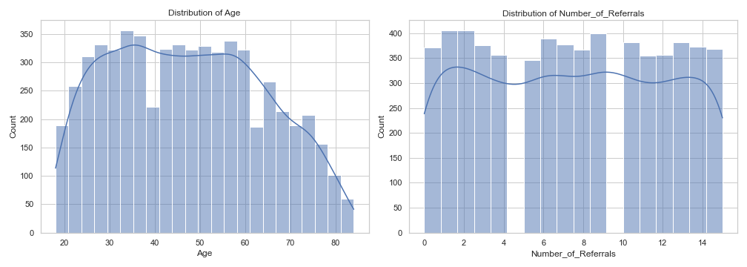
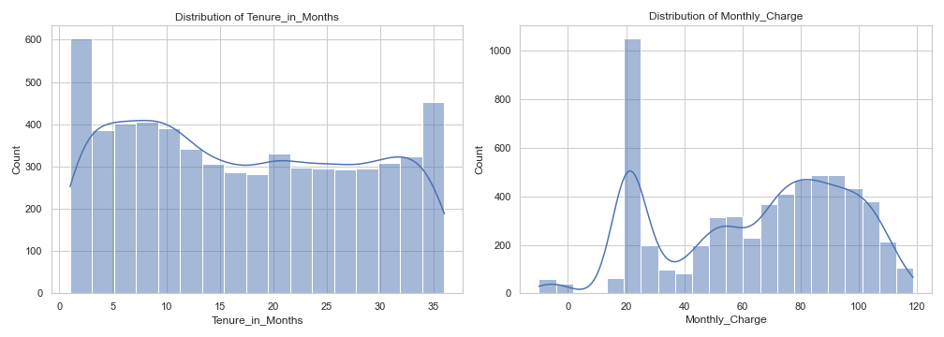
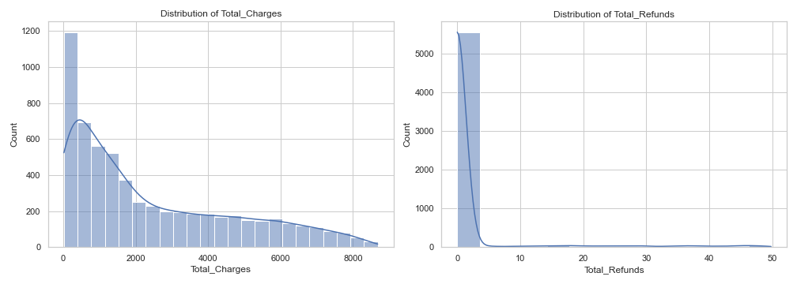
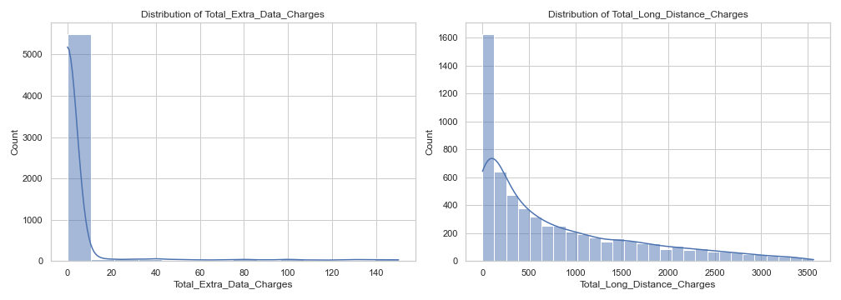

Key Observations
- Age and Tenure are well spread: diverse customer base with no extreme clustering.
- Billing-related features (Monthly/Total Charges) are right-skewed: few customers generate the highest revenue.
- Usage-based features (Extra Data & Long-Distance Charges) show high skewness: only a minority of users consume heavy add-ons.
- Low referral count overall: Number of Referrals shows most customers are single-referral users, suggesting limited peer-driven acquisitions i.e. Limited organic acquisition.
- Total refunds are concentrated at the lower end, suggesting that refund requests are rare, but the small number of high-refund cases may hint toward dissatisfaction among specific segments.
About Outliers:
Most variables — particularly Total Charges, Monthly Charges, Add-on Usage, and Refunds — exhibit outliers due to a very small group of heavy-spending or refund-claim customers. These outliers are not errors but genuine behavioral variations. Removing them would erase meaningful customer segments such as high-value users or high-risk refund seekers.
Bivariate Analysis:
c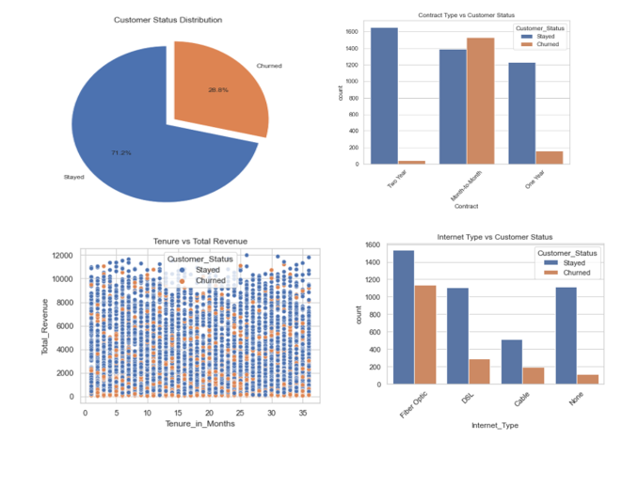

Key Observations: Customer Behaviour & Drivers of Churn
- Overall churn rate stands at approx. 29%, indicating that nearly one-third of the customer base is at risk, a material challenge for long-term revenue stability.
- Contract type shows strong influence on churn: customers on month-to-month contracts churn the most, while two-year contract customers show the highest retention — highlighting the value of long-term plans in customer stickiness.
- Tenure and revenue move together: customers who have stayed longer tend to contribute significantly higher total revenue, while churned customers are disproportionately concentrated in the early months of service, signalling early-stage dissatisfaction.
- Internet service type impacts churn: Fiber Optic users show higher churn than DSL or Cable users, hinting at experience or pricing issues specific to that segment; customers with no extra service show mostly retention, suggesting wireless-only segments are not at churn risk.
Correlation Insights
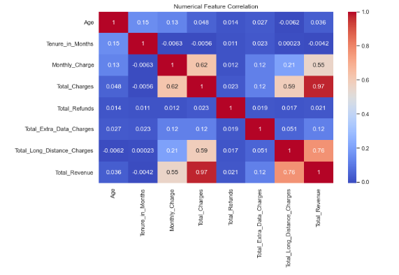
Numerical correlation matrix revealed:
- Total Revenue ≈ Total Charges (high correlation as expected)
- Monthly Charge moderately correlates with churn-associated features
  - Customers who pay high monthly fees usually generate higher revenue, especially when paired with long-distance usage.
  - But if high monthly fees are not matched with loyalty/tenure, they may become high-risk churn customers due to pricing sensitivity.
  - Monthly_Charge does NOT correlate strongly with tenure (≈ −0.006), meaning customers paying higher charges are not necessarily long-term customers.
- Refund-related fields show low correlations individually but are important churn signals behaviourally.
  - Refunds often represent service failure, billing disputes, or dissatisfaction.
  - Even small refund incidents can become triggers for customer frustration.

Machine Learning: Churn Prediction Model
Why Random Forest?
Random Forest was selected because:
- It handles categorical + numerical variables well
- It is robust to outliers and non-linear relationships
- It reduces the risk of overfitting through bagging and ensemble learning
Modeling Steps
- Dropped non-predictive attributes (Customer_ID, Churn reason)
- Label-encoding used for categorical features
- Target encoding:
  - Stayed = 0
  - Churned = 1
- Data split: 80% training, 20% testing
- Model training using RandomForestClassifier
- Model evaluation using:
  - Confusion matrix
  - Classification report (precision, recall, F1-score)
- Created predictions on new joiners’ dataset, saving only customers predicted to churn

Business Value of the ML Model
The churn model enables:
- Early warnings for high-risk customers
- Customer-specific retention campaigns
- Revenue loss minimization through proactive engagement
- Sales & CRM prioritization based on churn risk probability.

Automation & Production Thinking
To make churn prediction operational:
Component | Function
Power BI Dashboard | Business insights + trends + churn persona profiling
Python/Random Forest | Generates churn probability for each customer
SQL Jobs / Stored Procedures | Automate customer data refresh
Scheduled Model Execution | Weekly churn score generation and export
Automated Alerts | Notify CRM/Retention team with high-risk customer list

This architecture transforms the solution from analysis to a data-driven decision system.
Key Takeaways
- Churn is not random — it correlates with short tenure, high charges, month-to-month contracts, and low add-on engagement.
- EDA provides the statistical foundation behind the insights shown in Power BI.
- Random Forest delivers strong predictive performance and is interpretable for business users.
- The project enables analytical reporting and operational value through automated churn alerts
Possible Future Enhancements
Improvement Area | Idea
Model | Use XGBoost / LightGBM for probability-based scoring
Customer Segmentation | Cluster churners by behavior for personalized offers
Financial Optimization | Retention campaign cost vs revenue preservation analysis
Real-Time Scoring | Deploy through an API for CRM applications

Final Statement
This project blends data analysis, business intelligence, and machine learning to solve a highly impactful telecom challenge. It not only identifies why customers churn but also who is likely to churn next, empowering telecom companies to protect recurring revenue and strengthen loyalty.

